In week 7, the team had their half presentation on Monday. After that, the team had two playtests, one on Tuesday with high school students, the other on Thursday with middle school students. High school students are the real users of our product, therefore it is great to playtest them as early as possible. In the future, we will have playtests with high/middle school students every week till soft opening.

**Feedback from Half Presentation**

The good news from the half presentation is that we are on the right track. However, the general concern from faculty is that the scope is too big. They believe that the team might be able to finish everything on time, however, we probably do not have enough time to make everything perfect.

Another feedback is for presentation skills. Faculty would like to hear more details from our presentation. We have a complex and large game, and it is difficult to explain everything in 15 mins, especially when faculty demands details rather than higher concepts. We need to practice more.

**Playtest with High/Middle school students**

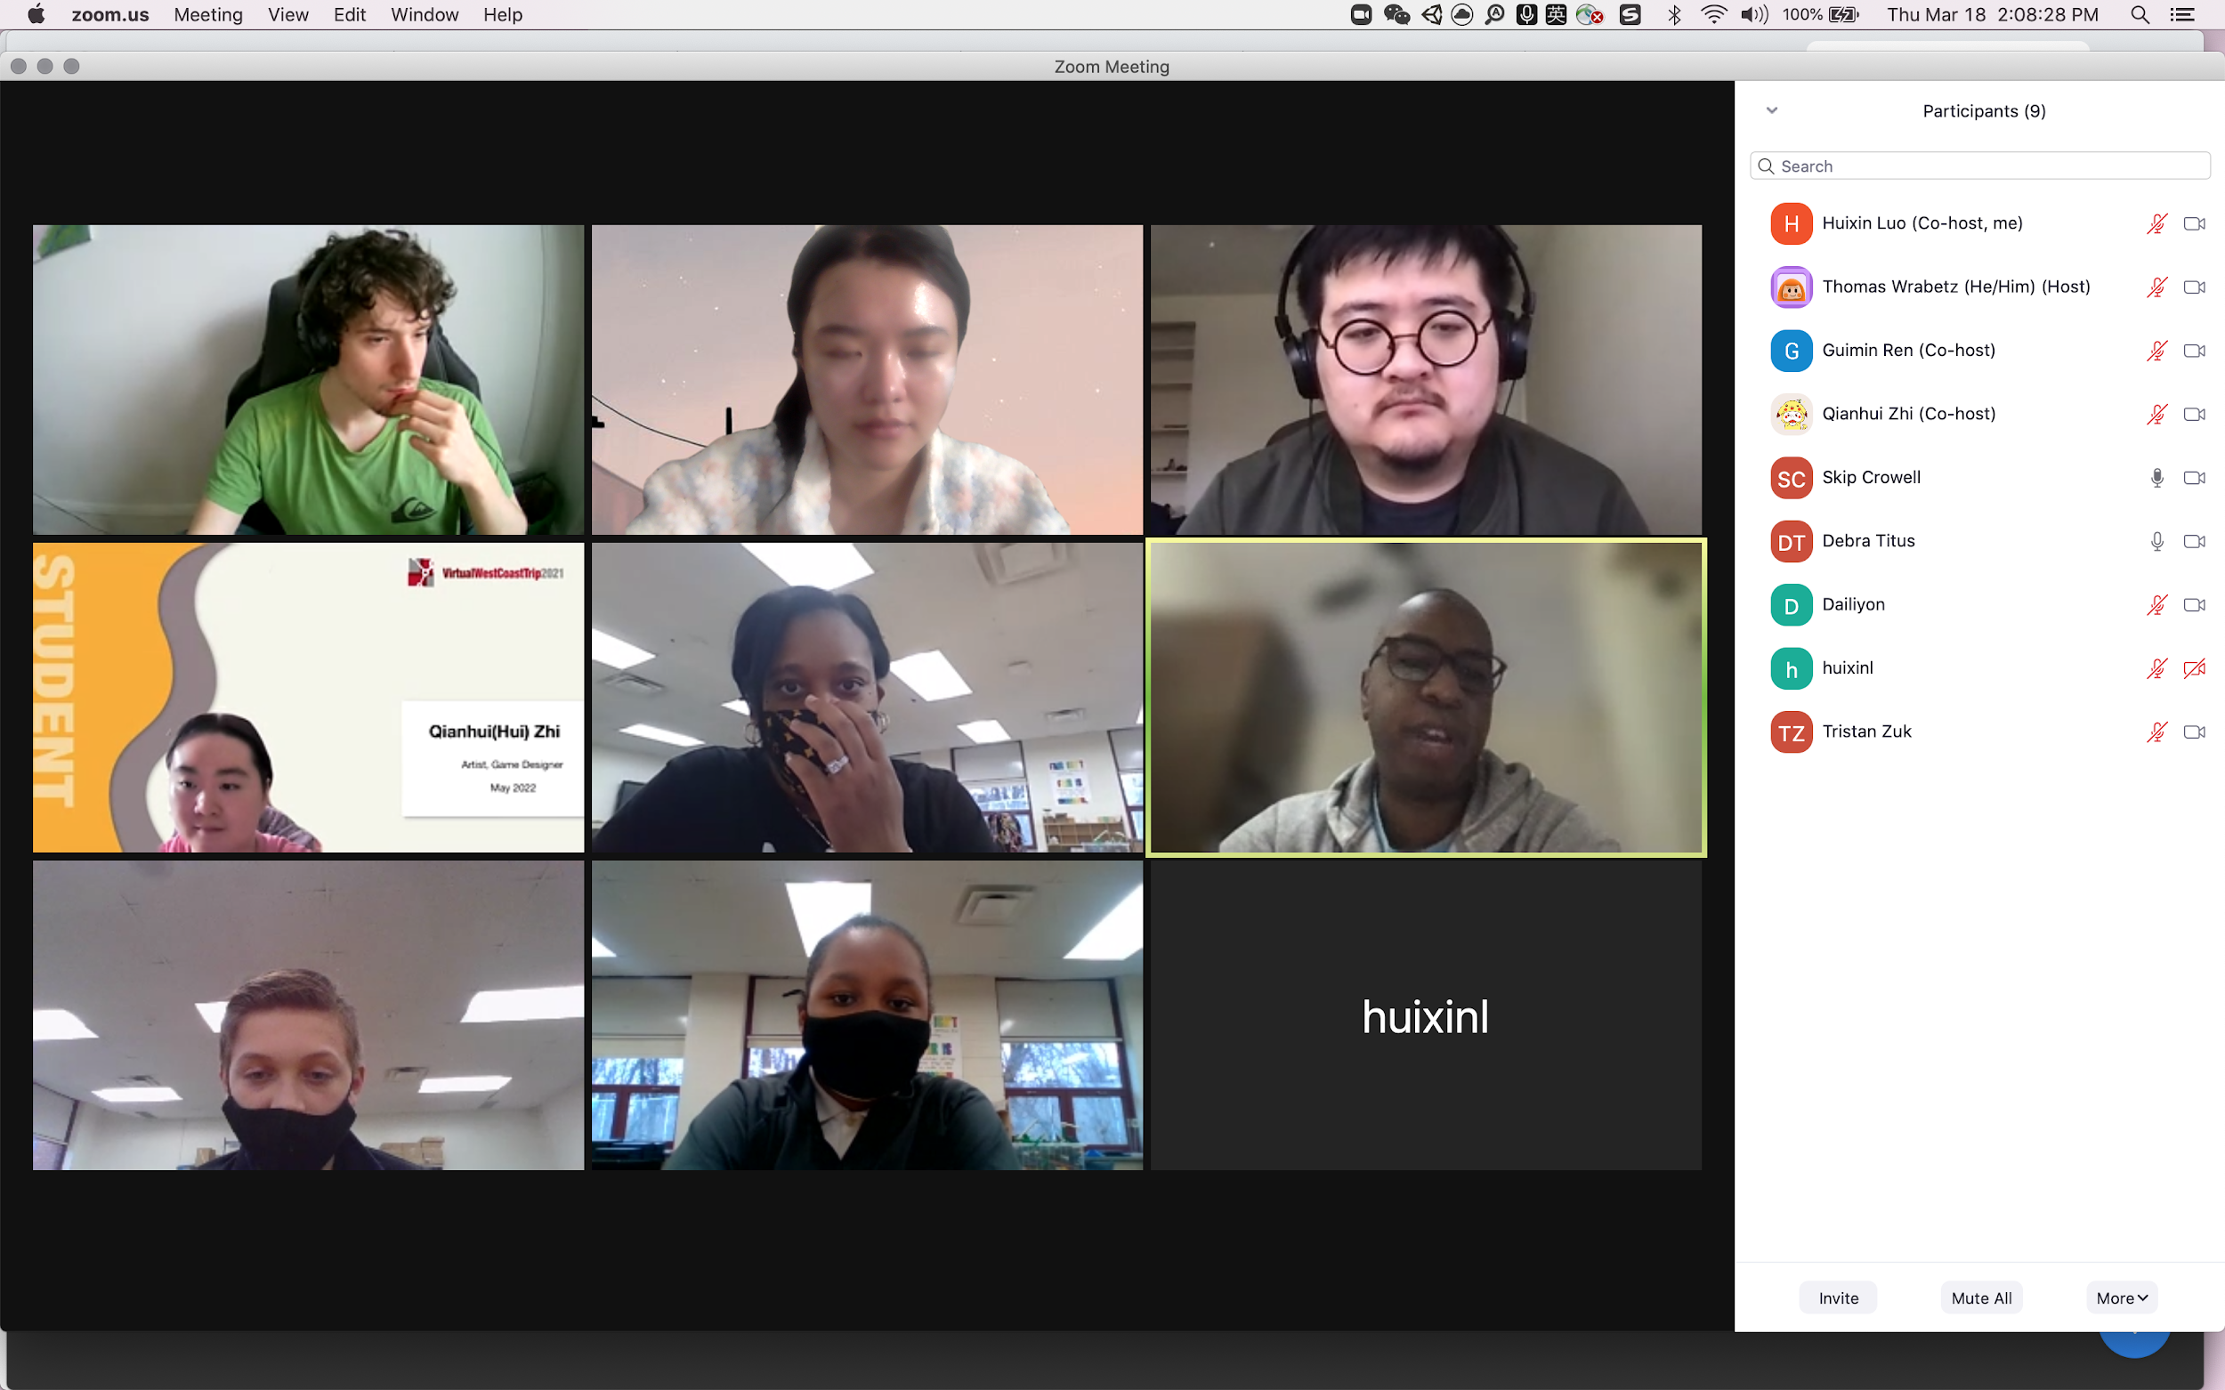

We had our playtest with high school students on Tuesday. They are from New York, and they are the exact target audience of our game. 5 students came to the playtest, and we held the playtest in Zoom.

We playtested the basics of our game: inventory, talking to customers, earning, banking account, and credit card. We did not get into loan nor stock in the playtest.

The playtest went smoother than we expected. All the playtests successfully played through the game without troubles and understand the concepts well. However, we do need to adjust the learning curve in the beginning. Some students did not get the concepts in the first encounter, after a few rounds, they gradually got the points. We do not need to make big changes to the game, however, there are a lots of tuning and tweaking for the team to refine, in order to make the experience smooth.

Overall, it is a big relief for the team that the playtests went smooth with our target audience.